 | RIVER VALLEY HIGH SCHOOL  YEAR 6 PRELIMINARY EXAMINATION

CANDIDATE NAME
CLASS | 6
CENTRE NUMBER | S |  |  |  |  |  |  |  | INDEX NUMBER

H1 CHEMISTRY |  |  | 8872/01
Paper 1 Multiple Choice |  |  | 22 September 2010  50 minutes
Additional Materials: | Multiple Choice Answer Sheet  Data Booklet
READ THESE INSTRUCTIONS FIRST

Write in soft pencil.
Do not use staples, paper clips, highlighters, glue or correction fluid.
Write your name, class, Centre number and index number on the Answer Sheet in the spaces provided.

There are thirty questions on this paper. Answer all questions. For each question there are four possible answers A, B, C and D.
Choose the one you consider correct and record your choice in soft pencil on the separate Answer Sheet.

Read the instructions on the Answer Sheet very carefully.

Each correct answer will score one mark. A mark will not be deducted for a wrong answer.
Any rough working should be done in this booklet.

________________________________________________________________________
This document consists of 12 printed pages.

Section A

For each question there are four possible answers, A, B, C and D. Choose the one you consider to be correct.

1 | 3 g of hydrogen gas reacted with 160 g of bromine gas to give hydrogen bromide, HBr, under standard conditions. How many molecules are present at the end of the reaction?
 | A | 6.02 x 10²³ | B | 9.03 x 10²³
 | C | 12.0 x 10²³ | D | 15.1 x 10²³

2 | 10 cm³ of a hydrocarbon was completely burnt in 100 cm³ of excess oxygen. When cooled to room temperature, the volume of residual gas obtained was 80 cm³. When the residual gas was passed through aqueous sodium hydroxide, the volume decreased to 20 cm³.  Which one of the following represents the structure of the hydrocarbon? (All volumes are measured at r.t.p.)
 | A | C₆H₁₂ | B | C₆H₁₀
 | C | C₆H₈ | D | C₆H₆

3 | 25.0 cm³ of 0.05 mol dm⁻³ KClO₄(aq) required 50.0 cm³ of 0.20 mol dm⁻³ TiCl₃(aq) to reach end-point. Given that Ti(III) ion is oxidised to Ti(IV) ion in this reaction, which one of the following formulae represents the reduction product of the ClO₄⁻ ion?
 | A | Cl ⁻ | B | ClO⁻
 | C | ClO₂⁻ | D | ClO₃⁻

4 | The table below gives the successive ionisation energies for an element X.  What could be the formula of the chloride of X?
   | 1st | 2nd | 3rd | 4th | 5th | 6th
  ionisation energy /kJ mol⁻¹ | 950 | 1800 | 2700 | 4800 | 6000 | 12300
 | A | XCl | B | XCl₂
 | C | XCl₃ | D | XCl₄

5 | Consider the following particles.  Which one of the following species has more electrons than neutrons and more neutrons than protons?
  particle | number of neutrons | number of nucleons
  P | 16 | 33
  Q | 18 | 35
  R | 17 | 34
  S | 16 | 31
 | A | P | B | Q⁺
 | C | R²⁻ | D | S³⁻

6 | Which of the following ions would be deflected the least when a beam is passed through an electric field?
 | A | 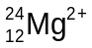 | B | 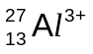
 | C | 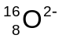 | D | 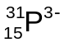

7 | Which of the following does not have a planar structure?
 | A | NO₃⁻ | B | H₂C₂O₄
 | C | ICl₄⁻ | D | H₂C=C=CH₂

8 | Which quantity would best indicate the relative strengths of the hydrogen bonds between the molecules in liquid hydrogen halides?
 | A | enthalpy changes of vapourisation
 | B | enthalpy changes of formation
 | C | enthalpy changes of solution
 | D | bond dissociation energies

9 | Which equation represents the standard enthalpy change of atomisation of bromine?
 | A | Br₂(l) → 2Br(g)
 | B | Br₂(g) → 2Br(g)
 | C | ½Br₂(l) → Br(g)
 | D | ½Br₂(g) → Br(g)

10 | It is often said that the rate of a typical reaction is roughly doubled by raising the temperature by 10 °C.  What of the following statements best explains this observation?
 | A | Raising the temperature by 10 °C doubles the average energy of each reactant particle.
 | B | Raising the temperature by 10 °C doubles the average speed of the reactant particles.
 | C | Raising the temperature by 10 °C doubles the frequency of collisions of the reactant particles.
 | D | Raising the temperature by 10 °C doubles the number of reactant particles having more than a certain minimum energy.

11 | The reaction of hydrogen peroxide with iodide ions in an acidic solution can be monitored by an initial rates method.  H₂O₂(aq) + 2H⁺(aq) + 2I ⁻(aq) → 2H₂O(l) + I₂(aq)  The rate equation was found to be as follows:  Rate = k [H₂O₂][I ⁻]  What of the following statements is incorrect?
 | A | The overall order of the reaction is 2.
 | B | The value of the rate constant, k, is dependent on temperature.
 | C | The rate is independent of the hydrogen ion concentration.
 | D | The rate doubles when the concentration of all the reactants is doubled.

12 | An equilibrium can be represented by the following equation.  P(aq) + Q(aq)  2R(aq) + S(aq)  In a certain mixture, the equilibrium concentration of Q is 10 mol dm⁻³.  What will the new equilibrium concentration of Q be if 5 mol of pure Q is dissolved in the mixture?
 | A | between 10 mol dm⁻³ and 15 mol dm⁻³
 | B | between 5 mol dm⁻³ and 10 mol dm⁻³
 | C | 15 mol dm⁻³
 | D | 10 mol dm⁻³

13 | In an acid-base titration, a 0.20 mol dm⁻³ solution of a base is added to 25 cm³ of a 0.10 mol dm⁻³ solution of an acid.  The pH value of the solution is plotted against the volume of base added, V, as shown in the diagram.  V /cm³  1  3  5  7  9  11  13  12.5  25.0  pH  This diagram could represent a titration between
 | A | CH₃COOH(aq) and NH₃(aq).
 | B | HCl(aq) and Ba(OH)₂(aq).
 | C | H₂SO₄(aq) and NaOH(aq).
 | D | HNO₃(aq) and NH₃(aq).

14 | An element X is a solid with a low conductivity at room temperature. It forms only one chloride, which is a liquid at room temperature and a non-conductor of electricity. The chloride of X hydrolyses in water, forming a white solid and a strongly acidic solution.  Which of the following elements could X be?
 | A | aluminium
 | B | phosphorus
 | C | silicon
 | D | sulfur

15 | Which property of the oxides of Period 3 elements (sodium to phosphorus) decreases from Na₂O to Al₂O₃ and also from SiO₂ to P₄O₁₀?
 | A | melting point
 | B | covalent character
 | C | pH of the resultant solution when the oxide is mixed with water
 | D | solubility in aqueous alkali

16 | Consider the following reaction :  Cl₂(g) + 2H₂O(l) + SO₂(g) → 2HCl(aq) + H₂SO₄(aq)  Cl₂(g) + H₂S(g) → 2HCl(aq) + S(s)  SO₂(g) + 2H₂S(l) → 2H₂O(l) + 3S(s)  What can be deduced about the strength of the three reacting gases as reducing agents?
 |  | strongest |  | weakest
 | A | hydrogen sulfide | chlorine | sulfur dioxide
 | B | chlorine | sulfur dioxide | hydrogen sulfide
 | C | hydrogen sulfide | sulfur dioxide | chlorine
 | D | sulfur dioxide | hydrogen sulfide | chlorine

17 | Which of the following is the least likely product formed in the termination step in the reaction of ethane with chlorine in the presence of uv light?
 | A | HCl | B | CH₃CH₂Cl
 | C | CH₃CHCl₂ | D | CH₃CH₂CH₂CH₃

18 | How many isomeric alkenes are there with the molecular formula C₄H₈?
 | A | 2 | B | 3
 | C | 4 | D | 5

19 | When compound Y was heated with acidified potassium manganate(VII), a gas was produced which gave a white precipitate when passed into limewater.  Which of the following could not be Y?
 | A | CH₃OH | B | C₆H₅CH₂CH₃
 | C | CH₃CCHCHCH₃ | D | CH₃CH₂CHCH₂

20 | In which of the following reactions is elimination the major type of reaction?
 | A | 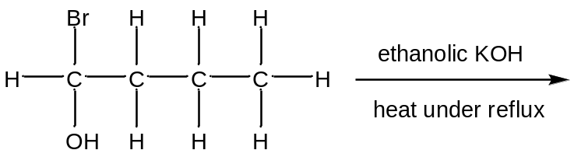
 | B | 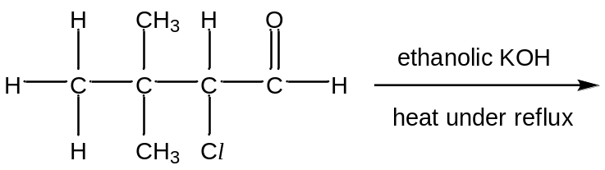
 | C | 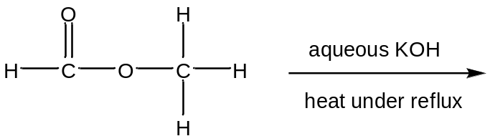
 | D | 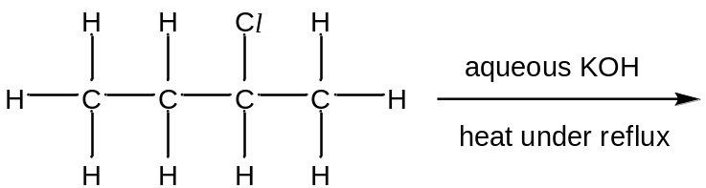

21 | Aldehydes and ketones are produced industrially by the catalytic oxidation of alkenes. For example, ethanal is manufactured from ethene as shown.  catalysta  H₂C=CH₂ + ½ O₂ ⎯⎯⎯⎯→ CH₃CHO  The process is also used industrially with but-2-ene, CH₃CH=CHCH₃.  Which compound is obtained from but-2-ene?
 | A | CH₃CH₂CHO | B | CH₃COCH₂CH₃
 | C | CH₃CH₂CH₂CHO | D | (CH₃)₂CHCHO

22 | Acidified potassium dichromate(VI) of concentration 1 mol dm⁻³ was added in parts to three separate test-tubes containing 10 cm³ of 1 mol dm⁻³ of unknown solutions X, Y and Z respectively. Each mixture was warmed and the observations are recorded below.  Which of the following could be the identities of X, Y and Z?
   | colour observed upon warming when
  solution | 1st part of 3.3 cm³ of K₂Cr₂O₇ was added | 2nd part of 3.3 cm³ of K₂Cr₂O₇ was added
  X | orange | orange
  Y | green | orange
  Z | green | green
 |  | X | Y | Z
 | A | C₆H₅CH₂OH | CH₃CH₂CH₂OH | CH₃CH₂CH₂CHO
 | B | CH₃CH₂CH₂CH₃ | CH₃C(OH)CHCH₃ | CH₃CHCHCH₂OH
 | C | CH₃CH₂CH₂COOH | CH₃CH₂CH₂CHO | CH₃CH₂COCH₃
 | D | (CH₃)₂C(OH)CH₂CH₃ | CH₃CH(OH)CH₂CH₃ | CH₃CH₂CH₂OH

23 | Dichlorodifluoromethane, CCl₂F₂, is widely used in aerosol propellants and as a refrigerant.  Which statement helps to explain why dichlorodifluoromethane is chemically inert?
 | A | The carbon-fluorine bond energy is large.
 | B | The carbon-fluorine bond has a low bond polarity.
 | C | Fluorine is highly electronegative.
 | D | Fluorine compounds are non-flammable.

24 | Which pair of reactions could have the same common intermediate?  W CH₃CH₂CH₃ → intermediate → (CH₃)₂CHCN  X CH₃CH(OH)CH₃ → intermediate → (CH₃)₂C(OH)CN  Y CH₃CH=CH₂ → intermediate → CH₃CH(OH)CH₃  Z CH₃CO₂CH₂CH₂CH₃ → intermediate → CH₃CH₂CH₂Br
 |  | A | W and X | B | W and Y
 |  | C | X and Z | D | Y and Z

25 | Tamoxifen is widely used in the treatment of breast cancer.  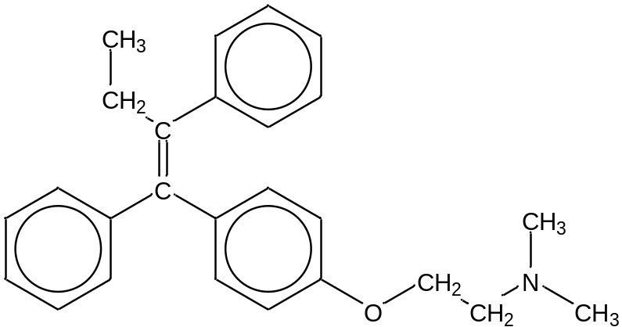  Tamoxifen  What is the number of sp² and sp³ carbon atoms respectively after subjecting Tamoxifen to hydrogen gas under heat and in the presence of nickel.
 |  | sp² | sp³
 | A | 6 | 20
 | B | 8 | 18
 | C | 18 | 8
 | D | 20 | 6

Section B

For each of the questions in this section, one or more of the three numbered statements 1 to 3 may be correct.

Decide whether each of the statements is or is not correct (you may find it useful to put a tick against the statements that you consider to be correct).

The responses A to D should be selected on the basis of

A | B | C | D
1, 2 and 3 are  correct | 1 and 2 only are  correct | 2 and 3 only are  correct | 1 only is  correct

No other combination of statements is used as a correct response.

26 | In which sequences are the molecules quoted in order of increasing bond angle within the molecule?
 | 1 | H₂O NH₃ CH₄
 | 2 | H₂O SF₆ BF₃
 | 3 | CH₄ CO₂ SF₆

27 | The equilibrium constant, K_{c}, for the reaction  X(g) + Y(g)  Z(g)  varies with temperature as shown in the diagram below.  K_{c}  T  Which conclusions can be drawn from the given information?
 | 1 | The equilibrium mixture contains a greater proportion of Z at higher pressures.
 | 2 | The equilibrium mixture contains a greater proportion of Z at higher temperatures.
 | 3 | The reaction is endothermic in the forward direction.

The responses A to D should be selected on the basis of

A | B | C | D
1, 2 and 3 are  correct | 1 and 2 only are  correct | 2 and 3 only are  correct | 1 only is  correct

No other combination of statements is used as a correct response.

28 | The diagram below represents the reaction profile of a particular reaction.  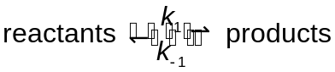  energy  reaction pathway  reactants  products  ΔH  E_{a}  Which of the following will cause both of the rate constants of the forward and backward reactions, k₁ and k₋₁, to be increased?
 | 1 | introducing a catalyst
 | 2 | heating the equilibrium mixture
 | 3 | increasing the concentrations of both the reactants and products

29 | Compounds containing CN⁻ ions are toxic. It is known that 50 mg of CN⁻ ions will be fatal to human beings.  Which of the following compounds do not contain free CN⁻ ions in their aqueous solutions?
 | 1 | CH₃CN
 | 2 | HCN
 | 3 | NH₄CN

The responses A to D should be selected on the basis of

A | B | C | D
1, 2 and 3 are  correct | 1 and 2 only are  correct | 2 and 3 only are  correct | 1 only is  correct

No other combination of statements is used as a correct response.

30 | Which reagents will convert ethanol into bromoethane?
 | 1 | red phosphorus and bromine
 | 2 | sodium bromide and sulfuric acid
 | 3 | aqueous bromine

END OF PAPER

